

T H E I S L A M I C U N I V E R S I T Y
Al-Diwaniyah Branch
Faculty of Pharmacy

The Technological Evolution of Microsoft Word: 2010–2026
A Comprehensive Analysis of How Microsoft Word Transformed from an Offline Typing Tool into a Cloud-Based, AI-Driven Writing Platform — and Its Direct Impact on Healthcare Documentation and Pharmaceutical Education

Submitted by: Baraa Emad Badri
Stage: First Stage
Subject: Computer Science
Submitted to: Dr. Ziad
Date: 10 May 2026

Introduction

Microsoft Word has maintained its position as the dominant word processing application for more than three decades, a longevity that is not the product of market inertia but of sustained architectural adaptation. From its earliest days as a graphical text editor on MS-DOS to its current status as a cloud-connected, AI-assisted writing platform, Word has continuously re‐ structured its underlying architecture, distribution model, and mode of user interaction in response to shifts in computing infrastructure and user expectations. Between 2010 and 2026, this adaptation accelerated dramatically, driven by the rise of cloud computing, mobile-first design, and artificial intelligence.
This report examines six major releases of Microsoft Word spanning this period: Word 2010, 2013, 2016, 2019, 2021, and the projected 2026 version. For each release, the analysis identifies the features that were introduced, the capabilities that were modified or replaced, and the features that were removed or deprecated. The report traces three broad phases of development interface refinement, cloud-based collaboration, and artificial intelligence integration that define the trajectory of Word's evolution. It also addresses the historical origins of the application and the strategic decisions that shaped its market dominance.
A central consideration throughout this analysis is the relevance of these changes to pharmacy students and healthcare professionals. Microsoft Word is not a peripheral tool in pharmaceutical education; it is the primary environment in which drug monographs are compiled, clinical case reports are formatted, pharmaceutical research papers are written, adverse drug reaction documentation is prepared, and patient education materials are developed. Changes to how Word handles formatting, collaboration, equations, and content generation therefore have direct and measurable implications for the quality, accuracy, and efficiency of pharmaceutical documentation.

Key Focus:
Understanding how this tool has evolved is not merely a technological exercise — it is a recognition that the software used for documentation directly shapes the quality of work in healthcare education and clinical practice.

The Origin of Microsoft Word

Microsoft Word was developed by Charles Simonyi and Richard Brodie, two software engineers working at Microsoft in the early 1980s. Simonyi's contribution was particularly significant: before joining Microsoft, he had worked at Xerox PARC, where he was involved in the
development of the Bravo text editor — one of the earliest programs to implement a

WYSIWYG (What You See Is What You Get) interface. This principle, which allowed users
to see formatted text on screen as it would appear when printed, became the foundational design philosophy of Word and distinguished it from the command-line-driven tools that dominated the market at the time.
The first version of the application was released in 1983 under the name Multi-Tool Word for Xenix, a Unix-based operating system developed by Microsoft. A version for MS-DOS followed later that same year, and a Macintosh version was released in 1985. At the time, the word processing market was dominated by WordPerfect and WordStar, both of which Operated through command-line interfaces requiring users to memorize keystroke combinations for formatting tasks. Word's graphical, mouse-driven approach represented a meaningful departure from this paradigm, offering a more intuitive way to create and format documents. However, commercial adoption was initially slow, as existing users were deeply entrenched in their command-line workflows.
Word's market position changed substantially with the release of Windows 3.0 in 1990. Because Word was developed by the same company that produced the operating system, it was tightly integrated with the Windows platform and benefited directly from Windows' rapid adoption in offices, government institutions, and universities. By the mid-1990s, Word had become the dominant word processor globally. The tight coupling between Word and Windows created a feedback loop: as Windows became the standard operating system, Word became the standard document tool.
Several key developments between Word's initial release and the period covered by this report shaped the application's trajectory. Word 97 introduced the Office Assistant, an animated help character that was widely criticized and eventually removed. Word 2003 represented the final version to use the traditional menu-and-toolbar interface. Most importantly, Word 2007 re‐ placed this interface with the Ribbon — a tabbed command bar that became the standard for

all subsequent versions. Word 2007 also introduced the .docx file format, based on the Open XML standard, which replaced the legacy .doc format as the default. The versions examined in this report build directly on this foundation.
1

Microsoft Word 1.0 — MS-DOS
File Edit View Format
Early MS-DOS text editing environment

Figure 1: Early Microsoft Word interface for MS-DOS, showing the original graphical text editing environment.

Microsoft Word 2010

Released: June 15, 2010 — Part of Microsoft Office 2010

Word 2010 marked a shift in Microsoft's development philosophy: rather than restructuring the interface again, the company focused on improving file management and accessibility. The most prominent change was Backstage View a full-Screen interface that replaced the Office Button and provided centralized access to saving, printing, sharing, and document properties. This was a deliberate move away from cosmetic changes toward practical work‐ flow improvements that made everyday document tasks faster and more transparent.
The release also introduced the Screenshot capture tool, which allowed users to insert screen grabs from external applications directly into a document without leaving Word. For pharmacy students, this was directly applicable to lab report preparation, where diagrams from analytical instruments or entries from online drug databases such as PubChem or DrugBank needed to be incorporated into formatted documents. Enhanced image editing with artistic filters, color correction, and background removal further reduced the need for external image software.
Additional features included Protected View for opening potentially unsafe files in a read- only sandbox, OpenType typography support for ligatures, and co-authoring through SharePoint Workspace — though this last feature was limited to local network environments and excluded most individual users.
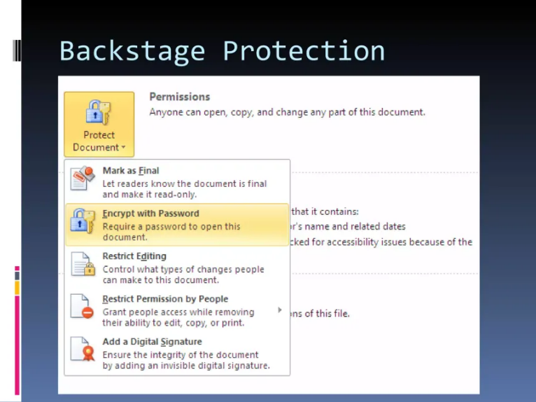
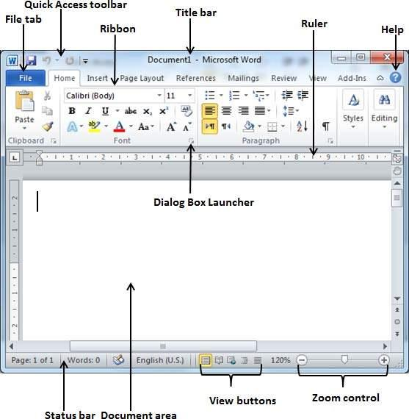

Figure 2: Microsoft Word 2010 Interface showing Backstage View
12

Microsoft Word 2013

Released: January 29, 2013 — Part of Office 2013 / Office 365

Word 2013 was developed alongside Windows 8 and reflected Microsoft's strategic emphasis on tablet computing and cloud-first software delivery. The most consequential change was architectural: OneDrive (rebranded from SkyDrive) became the default save location for new documents, fundamentally shifting the assumption that files lived on a local hard drive. This single decision laid the infrastructure for every collaborative and cloud-dependent feature that followed.
The release introduced Read Mode for distraction-free on-screen reading, Touch Mode with enlarged interaction targets for tablet navigation, and Resume Reading, which bookmarked the user's last cursor position across devices. But the feature with the most direct impact on academic work was PDF Reflow — the ability to open and edit PDF files directly within Word without external conversion tools.

Pharmacy Application:
Published drug information PDFs, clinical guidelines, and pharmacokinetic research papers could now be opened and edited directly, without relying on third-party converters that often distorted formatting.

The built-in Clip Art library was discontinued and replaced by Bing Image Search, marking one of the first visible removals in Word's modern evolution. This represented a broader strategic shift from local asset libraries toward cloud-powered web services, a pattern that would continue in subsequent releases.
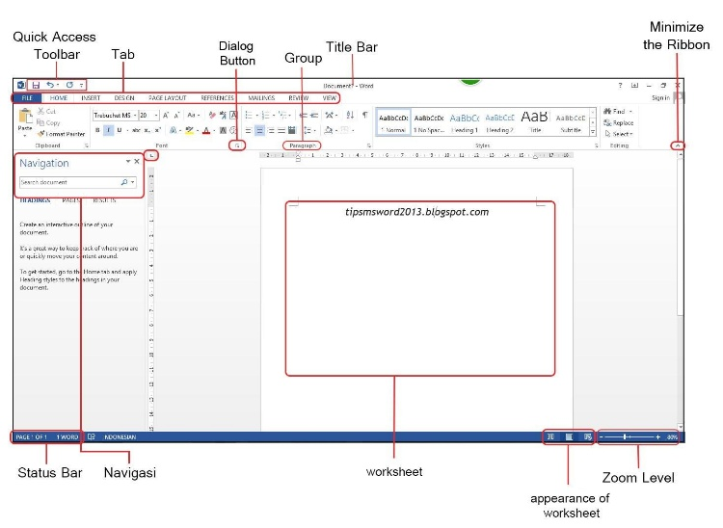

12
Figure 3: Microsoft Word 2013 Interface

Microsoft Word 2016 — The Collaboration Era

Released: September 22, 2016 — Part of Office 2016 / Microsoft 365

Word 2016 was developed around a single, transformative principle: document creation is a team activity, not an individual task. The central feature real-time co-authoring had been partially available in earlier versions through SharePoint but was now implemented as a core capability across all platforms. Multiple users could open the same document simultaneously, see each other's live cursor positions, and edit in real time without overwriting each other's work. This eliminated the unreliable and error-prone workflow of emailing document versions back and forth the infamous cycle of "Document_Final_v2_FINAL_actually_FINAL.docx" that had plagued group work for years.
The release also introduced the Tell Me assistant, a natural language command search that al‐ lowed users to type what they wanted to do and receive direct actions rather than help articles. Smart Lookup, powered by Bing, provided contextual web results within a side panel, allowing users to research terms or verify facts without leaving the document. Additional features included new chart types such as treemap, sunburst, and waterfall for data visualization, a Version History pane for browsing and restoring previous drafts stored on OneDrive, and an Insights Pane that surfaced relevant web information for selected text.

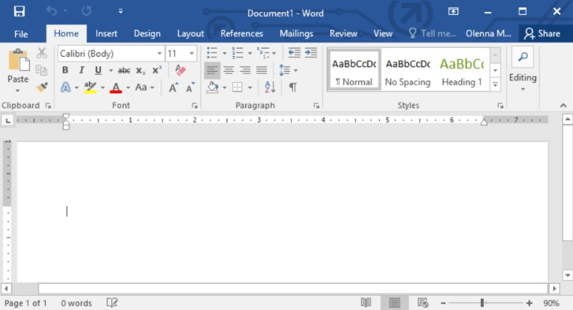

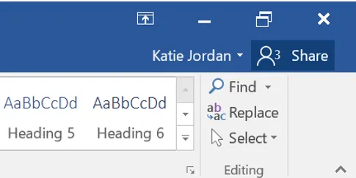

Figure 4: Microsoft Word 2016 showing real-time co-authoring with multiple collaborators editing simultaneously.

Impact on Pharmacy Education:
Group research projects, systematic literature reviews, and multi-author clinical case reports could now be written collaboratively in a single document. Contributors could see each other's edits as they happened, divide sections without creating conflicting copies, and resolve disagreements in real time — particularly valuable for pharmacy programs where group
assignments involving drug therapy reviews and evidence-based research papers are standard
curriculum components.

OneDrive integration deepened with automatic saving for all cloud-stored documents. A dark theme option was added for the first time. However, co-authoring required a stable internet connection and OneDrive or SharePoint access, and sync conflicts occasionally occurred. Full functionality also required an active Microsoft 365 subscription, creating an ongoing cost that not all students could afford.

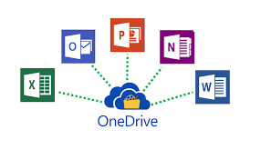

Figure5: Microsoft Onedrive integration with Microsoft Word 2016 collaborative features.
.

Microsoft Word 2019

Released: September 24, 2018 — Standalone One-Time Purchase

By 2019, Microsoft had established a clear split in its product strategy: a continuously up‐ dated subscription model (Microsoft 365) and a stable, one-time purchase model for users who preferred to avoid recurring costs. Word 2019 was built for the latter group. Rather than introducing new cloud-dependent capabilities, it consolidated the most mature tools from the subscription version into a stable, offline-capable product.
The most significant addition for academic and scientific writing was native LaTeX equation syntax. Before Word 2019, writing complex mathematical notation including pharmaceutical dosage calculations, pharmacokinetic modeling equations, and chemical structural formulas required third-party tools such as MathType, which often produced formatting inconsistencies when documents were shared across different systems. With LaTeX support built directly into Word's equation editor, pharmacy students and researchers could write these expressions using standard LaTeX notation and have them rendered natively within the document.
Additional features included Learning Tools (Read Aloud, adjustable text spacing, syllable- level word breaks), a built-in translator, Focus Mode for distraction-free writing, digital inking with pressure sensitivity, and SVG image support. These additions reflected Microsoft's recognition that academic and professional users needed specialized tools beyond basic text formatting.

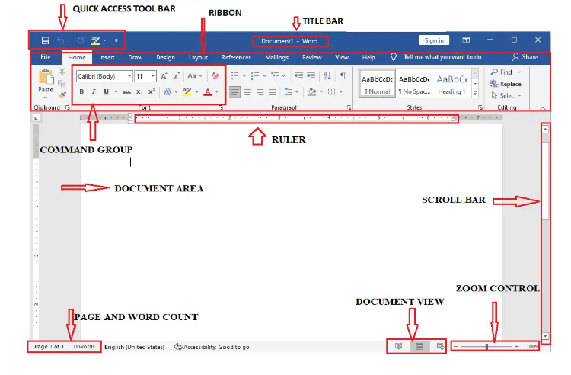

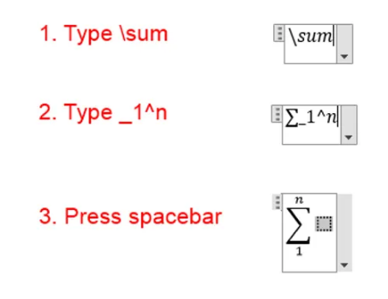

Figure 6: Microsoft Word 2019 showing native LaTeX equation support with a pharmacokinetic formula.

Microsoft Word 2021

Released: October 5, 2021 — Standalone One-Time Purchase

Word 2021 continued the standalone product model but made a notable concession to the cloud era: real-time co-authoring with automatic saving via OneDrive was included in a standalone release for the first time. This meant that Students and professionals without a Microsoft 365 subscription could now participate in collaborative document editing without purchasing a recurring license.
Released alongside Windows 11, the visual design adopted the new operating system's aesthetic softer corner radii, a neutral color palette, and a more refined typographic treatment. Dark mode was extended to the document canvas itself, not just the application frame, which was a practical benefit for pharmacy students working during late-night study sessions and reducing eye strain during prolonged document editing.
The release also introduced Line Focus within Immersive Reader, XLOOKUP for more flexible data searches in tables, an improved dictation engine with automatic punctuation, and Microsoft Teams integration for initiating calls directly from within a document.

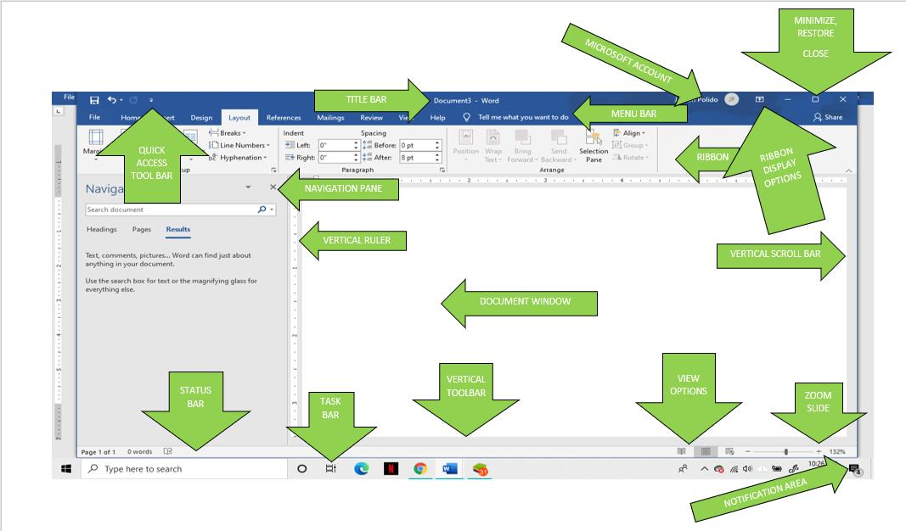


Figure 7:Microsoft Word 2021 and its modern interface features.

Microsoft Word 2026 — The AI-Powered Future

Projected Release: 2026 — Microsoft 365 Subscription

The projected 2026 version represents the most fundamental architectural shift in Word's history since the Ribbon interface replaced traditional menus in Word 2007. Rather than a conventional word processor with artificial intelligence feature added as supplementary tools, Word 2026 is expected to operate as an AI-first writing environment in which Microsoft Copilot is embedded into every stage of the document workflow. The user's role shifts from manually executing each formatting and editing action the "typist" model to directing an AI system that understands context, intent, and domain-specific language. The user be‐ comes a director, providing professional judgment and strategic intent while the AI handles drafting, formatting, and content generation.
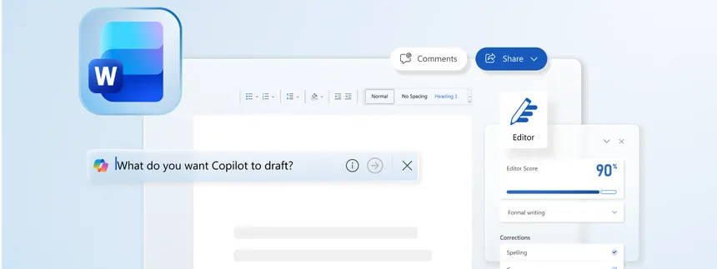
The core of this transformation is Microsoft Copilot, powered by large language models integrated directly into the Word interface. Copilot will be capable of drafting documents from brief prompts, summarizing lengthy reports into concise abstracts, rewriting passages to match a desired tone or register, and generating adaptive document templates that learn from the user's writing patterns. For pharmacy professionals, this has immediate practical applications: a pharmacist could provide Copilot with clinical trial data points and receive a structured drug information leaflet as a first draft, or dictate a patient consultation summary and have it formatted into a standardized clinical note within seconds.
Figure 8: Microsoft Word 2026 Conceptual Interface showing Copilot AI actively generating document content.

Advanced dictation capabilities in the 2026 version are expected to include contextual under‐ standing and recognition of medical and pharmaceutical terminology. Generic speech recognition tools frequently misinterpret drug names, dosing terminology, and clinical abbreviations
errors that can have serious consequences in healthcare documentation. Word 2026's anticipated medical dictation engine aims to address this gap, allowing pharmacists to transcribe clinical notes from hospital rounds, patient consultations, or dispensing activities with significantly greater accuracy.

Professional & Ethical Consideration:
While AI can draft a drug information leaflet, summarize a clinical trial, or generate a structured care plan, the pharmacist's professional judgment remains legally and ethically required to verify every piece of AI-generated content before it is finalized or distributed. Clinical accuracy, regulatory compliance, and patient safety cannot be delegated to an algorithm.



Features Added and Removed Over the Years

Examining the pattern of feature additions and removals across the six versions reveals a consistent strategic logic behind Microsoft's development decisions. Features are rarely removed arbitrarily. When Microsoft deprecates a capability, it is typically because the technology has become outdated, user adoption has declined, or the functionality has been absorbed into a broader, cloud-connected system that serves the same purpose more effectively. The removal of standalone desktop features and their replacement with cloud-dependent equivalents is a deliberate strategy to drive users toward the subscription-based Microsoft 365 ecosystem.

Feature Removed | Version | Replaced By
Classic menu-and-toolbar interface | Word 2007 | Ribbon interface
Office Assistant ("Clippy") | Word 2007 | Tell Me assistant (Word 2016)
Clip Art library | Word 2013 | Bing Image Search
Research Pane | Word 2016 | Smart Lookup and Insights Pane
Equation Editor 3.0 | Word 2019 | Native LaTeX equation support
SkyDrive branding | Word 2013 | OneDrive

Three Phases of Development
Phase 1 — Interface and Usability (2010–2013): These versions concentrated on refining how users interacted with the application. Backstage View simplified file management, Read Mode improved on-screen reading, and touch support prepared Word for tablet-based work‐ flows. Cloud storage was introduced as an optional capability rather than a requirement.
Phase 2 — Collaboration and Connectivity (2016–2021): The focus shifted to enabling teams to work together through cloud infrastructure. Real-time co-authoring, automatic saving, and Teams integration made Word a collaborative platform. Academic tools — LaTeX support, Learning Tools, and improved accessibility features — were also added during this phase.
Phase 3 — AI Integration (2026): The projected 2026 version initiates the era of AI-first document creation. Rather than the user performing every action manually, AI assists with drafting, summarizing, editing, and translating.

Conclusion

The progression of Microsoft Word from 2010 to 2026 represents a sixteen-year journey from a static, locally installed desktop application to an intelligent, cloud-connected writing plat‐ form capable of understanding context, intent, and domain-specific language. Each version examined in this report introduced changes that were not arbitrary additions but deliberate responses to observable shifts in how individuals and organizations create, share, and manage documents. The trajectory moved through three distinct phases — interface refinement, cloud- based collaboration, and artificial intelligence integration — each building on the foundation of the one before it.
For pharmacy students and healthcare professionals, the practical impact of this evolution is measurable and ongoing. The early improvements in file management and image handling simplified the assembly of lab reports and drug monographs. PDF Reflow enabled direct editing of published research papers. Real-time co-authoring eliminated the version control problems that had previously made group research projects inefficient and error-prone. LaTeX equation support addressed a specific and previously unmet need in pharmaceutical scientific writing. And the AI capabilities projected for 2026 promise to reduce the time required for routine drafting of drug information leaflets, structured care plans, adverse event reports, and literature summaries allowing pharmacy professionals to allocate more of their time and attention to clinical reasoning, patient counseling, and evidence evaluation rather than fighting with formatting and repetitive phrasing.
Across every version, the consistent trajectory has been toward reducing manual effort and enabling users to focus on the substance of their work rather than the mechanics of the tool. As digital productivity tools continue to evolve, their influence on the accuracy, efficiency, and quality of healthcare documentation will only grow. Understanding how Microsoft Word has changed is not merely a technological overview — it is a recognition that the tools professionals use to communicate directly shape the quality of care, research, and education they deliver.

Summary:
From the Ribbon interface of Word 2007 to the AI-powered Copilot of Word 2026, each generation of Microsoft Word has redefined what it means to create a document — and with it, the standards of quality, collaboration, and efficiency expected in pharmaceutical education and healthcare practice.

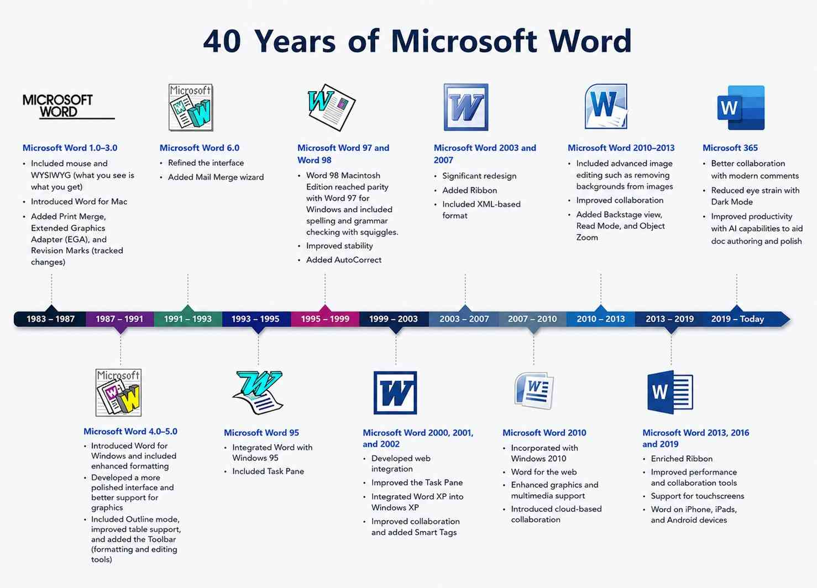

Figure 9:Evolution of Microsoft Word over the years

